|  |  |
| --- | --- |
| **HPWHsim Project Report** |  |

**Prepared for:**

Davis Energy Group and

Pacific Gas & Electric

**April 14, 2016**

**Prepared by:**

Nicholas Kvaltine

Michael Logsdon

Ben Larson

Ecotope, Inc.

# Executive Summary

The energy use of a HPWH is fundamentally different from purely electric resistive storage tank water heaters, mainly due to the fact that most HPWH's available today are “hybrid” units that include resistance elements along with their heat pumps and will engage either according to an internal logic specification. To help understand and estimate the amount of energy savings that can be achieved with Heat Pump Water Heaters (HPWHs), a HPWH simulation was developed and calibrated.

The incremental growth of the HPWH simulation that is now known as HPWHsim resulted in several limitations. Under this project, a number of new innovations were implemented to allow for easier model specification and better compatibility with other simulation packages. A message passing system was added, as well as the ability to specify new models quickly and relatively easily. The code of HPWHsim is made publicly available through the EcotopeResearch group on the github website. <https://github.com/EcotopeResearch/HPWHsim.git>

The original HPWH simulation was tested and calibrated thoroughly against field data. Some of the innovations could create different results, however, so it was necessary to revisit the previously collected field data and recalibrate certain aspects of the HPWH models. An interactive web application was created to explore the performance of various models against lab, and where available, field data: <https://ecotope.shinyapps.io/HpwhTestTool/>. Additionally, testing was done to compare the outputs from HPWHsim running under an Ecotope test platform against HPWHsim running within CSE. After several rounds of testing, the results matched within rounding errors.

Over the course of the project, we encountered several limitations of the data used to specify the performance models in the simulation. The data were collected at ambient temperatures suitable for a Northwest climate (50°F and 67.5°F) but not for hot, California climates. While the available data is likely to do a reasonable job predicting performance at warm temperatures, future projects should conduct lab investigations to measure HPWH performance at 95°F improve accuracy. With new data, the simulation can then be updated to account for more widely specified performance curves.

Overall, the HPWH simulation has undergone a substantial improvement. Being rewritten in C++ allows it to be included as a separate class, which makes its inclusion into other code simpler. As part of this process, it was also brought under version control using git, and github, which makes sharing the code far easier. The addition of news models of HPWH to HPWHsim can now be implemented radically faster and easier. Specifications can be tested at run time, optimizing parameters faster and easier than before. The important parameters were also reorganized in order to allow for more intuitive specifications. The sum of these changes means that HPWHsim, as the simulation is now called, is easier to use, more extensible, and more readily available than it has ever been. This should prove to be a boon to the entire field of electric storage tank water heater energy modeling.

# Introduction

Heat Pump Water Heaters (HPWHs) provide an economical way to substantially reduce the amount of energy used in domestic water heating which is the second largest use of electricity in residences.[1] It follows that the proper application of HPWHs can potentially have a large impact in reducing energy use. To help understand and estimate the amount of energy savings that can be achieved, a HPWH simulation was developed and calibrated.

A standard Electric Resistance Water Heater (ERWH) uses a predictable and regular amount of energy to produce a given amount of hot water. A simulation is hardly needed to estimate daily energy usage in this case. The energy use of a HPWH is fundamentally different, though, mainly due to the fact that most HPWH's available today are “hybrid” units that include resistance elements along with their heat pumps and will engage either according to an internal logic specification. Due to this, there can be a drastic difference in energy use for HPWH models with different logic and the same amount of water drawn, or even with the same unit if the draws are sufficiently different. For example, if all of the water was drawn at once, this would almost certainly cause resistance elements to engage, thus drastically lowering the efficiency of the HPWH. The time of day for energy use is increasingly more important however, and this is an aspect of water heating energy use, for any kind of storage-type water heater, that is hard to answer without a simulation.

This HPWH simulation was developed with whole house simulation in mind; it is intended to be run independently of the overarching simulation's time steps, other parameters, and does not aggregate its own outputs. It was also designed to run quickly, as the typical use case would see many simulations run, each a year-long or more.

The goal of the current project is to expand and extend the capabilities of the existing HPWH simulation, with a focus on making adaptations for specific use in the California code compliance context. The scope of work for this project included 5 tasks:

1. Refactor control strategy algorithm and reconfigure input parameters
2. Prepare for integration with CSE or other whole-house simulation tools
3. Support CSE Integration and Software Modifications
4. Create Generic HPWH Equipment models
5. Reporting and communications

# Task 1: Refactor control strategy algorithm and input parameters

The first task involved identifying the capabilities and limitations of the existing HPWH simulation. An extensive survey was done of existing equipment models and their parameters, identifying the crucial parameters and logical choices that would be needed in the new simulation. Then the needed innovations were outlined and fit into the framework of the simulation.

## Previous Versions of HPWHsim

The incremental growth of the HPWH simulation that is now known as HPWHsim resulted in a number of limitations. We (Ecotope) developed the original version of this simulation in order to help assess the impact of HPWH's on the energy consumption of the Pacific Northwest.[2] As such, it was built as a part of our whole house simulation, SEEM,[3] which was written strictly in the C programming language. It was also not easily extensible: values of the various parameters were built in, along with the logic used by each model to decide which heat source to use. This meant that the addition of a new model of HPWH would require a rewrite of the code, and for cases with unusual logic this could be extensive. Additionally, the parameters used to specify the way heat was distributed had a non-intuitive relation to the measured performance of a HPWH. As the capabilities of the simulation were extended, it became clear that each additional model was going to increasingly add to the complexity of the code.

## HWPHsim Innovations

As the number of HPWH models continues to expand and the importance of accurately modeling their energy use is more widespread, it became apparent that the HPWH simulation needed a major overhaul in order to increase its ability to remain useful in the future. A number of new innovations were implemented to allow for easier model specification and better compatibility with other simulation packages.

To allow for more flexibility in the specification of heat sources, the concept of “condensity” was developed. A portmanteau of “condenser” and “density”, the condensity represents the section of the tank in which a heat source will add the heat it generates. A resistance element, for example, would have a condensity concentrated entirely in one point.

HPWHsim now allows for an arbitrary number of heat sources and logic configurations. Previously, two resistance elements and a compressor were required, and their priority in deciding which to use was set. Now the logic is specifiable as well, by choosing from a set of standard decision criteria, such as the temperature of the top third of the tank, and supplying setpoints for those criteria.

**Figure 1.** Schematic representation of two different topologies of hybrid storage water heaters. The wrapping of condenser coils and position of resistance elements is represented by the condensity.

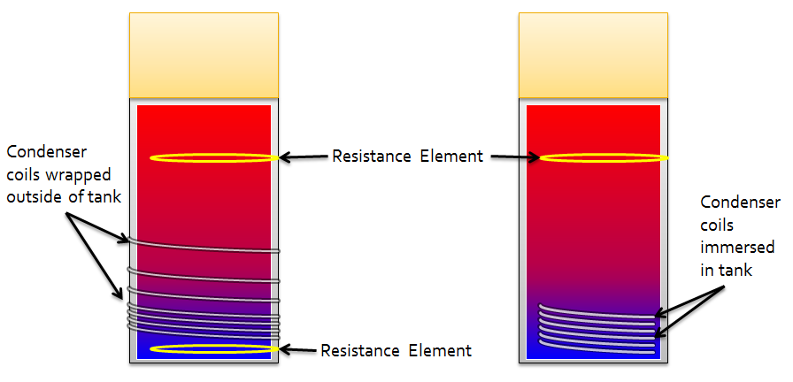

The ability to completely specify a HPWH model at run time via filename was also an important addition. Although there are still several built-in HPWH models, using the models we have measured and closely calibrated, it is now possible to quickly and easily create a set of parameters defining a HPWH model and run it through a simulation. This has allowed for substantially easier development of HPWH models and parameter sets.

Although the simulation does not model interaction with the environment (that is left up to the overarching, calling program), the ability to set up a ducted HPWH is available due to the separate specification of the evaporator temperature and the tank ambient temperature.

New to HPWHsim, a set of documents was created to explain the decisions and approximations made in creating the simulation. Additional documentation was created to explain the usage of HPWHsim and provide some guidance for the appropriate way to use it within another simulation.

# Task 2: Prepare for integration with CSE or other simulation tools

Integration with the California Simulation Engine (CSE), or more generally with other simulation tools, required a set of additions to the simulation structure.

Foremost, the entirety of the simulation was recoded in C++, which allows for greater encapsulation and increases the ability to utilize it within other programs. A number of other changes were made to consolidate the inputs and outputs in a way that was portable as well as easy to understand. This was crucial for developing an application programming interface (API) which would allow for HPWHsim to be included within other simulations.

Of particular use for integrating with non-SEEM whole-house simulations, a protocol for flagging errors and passing messages was developed. There are several levels of output that can be specified, ranging from no messages whatsoever, to a torrent of outputs that can be of use for extensive testing and debugging.

Additionally, a standard set of methods for exposing the output from the simulation was developed. Identifying all of the relevant outputs and variables and then creating functions to access them allows for custom outputs to be created, or a standardized output to be used when appropriate.

# Task 3: Support CSE Integration and Software Modifications

Part of the support for integration was to bring HPWHsim under version control. The version control software decided upon for this was git. A benefit to using git is the availability of github, a web based platform for hosting and sharing software under version control. The code of HPWHsim is made publicly available through the EcotopeResearch group on the github website. <https://github.com/EcotopeResearch/HPWHsim.git>

Another aspect to support is testing the new HPWHsim against previous data, as well as against its integration with CSE.

## Testing of new HPWHsim

The original HPWH simulation was tested and calibrated thoroughly against field data.[4] This process gave us confidence that the most significant approximations we are using, such as the nodal tank model and the linear assumption for COP and input power were valid and able to produce accurate results. Since these approximations form the basis of the simulation, most of the original validation still holds. Some of the innovations provide different results, however, such as the condensity model for heat distribution. Therefore it was necessary to revisit the previously collected field data and recalibrate certain aspects of the HPWH models. An interactive web application was created to explore the performance of various models against lab, and where available, field data: <https://ecotope.shinyapps.io/HpwhTestTool/>

**Figure 2**. The (old) standard DOE 24 hour test, as measured and simulated.

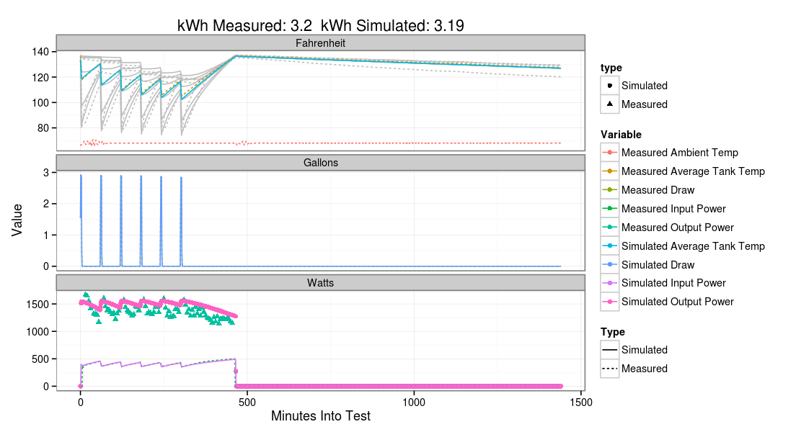

Additionally, testing was done to compare the outputs from HPWHsim running under an Ecotope test platform against HPWHsim running within CSE. Several rounds of testing were required, but results were able to be matched within rounding errors.

**Figure 3**. Comparison of the simulated and measured energy per day for the field data. Each point is one site; points on the dotted line match field and simulated energy use perfectly.

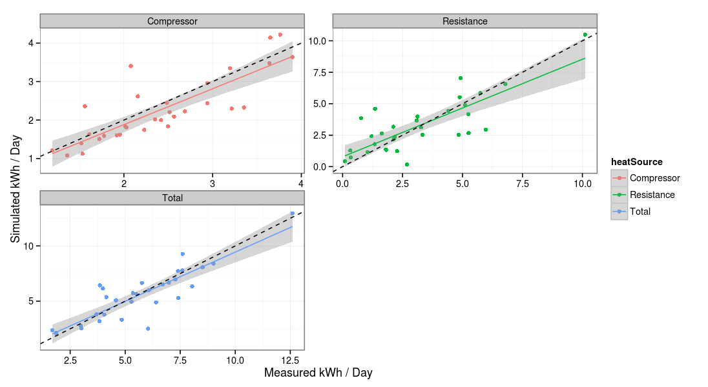

# Task 4: Create Generic HPWH Equipment models

Parameter sets for generic models were developed for HPWHsim. In the course of testing, parameters for existing models were collected and compared against each other. This allowed for the identification of the most important parameters for determining performance, as well as which parameters were identical or similar between existing models. Close collaboration was required to determine the intended uses for the generic models and to tailor their parameters to meet these goals.

Testing was done to ensure that the generic models performed approximately as desired. However, the nature of a generic model means that there is no lab of field data to test it against, therefore the relevance of the generic model to the reality of heating water with heat pumps is hard to estimate.

# Task 5: Reporting and communications

A full set of documents were created which explain the working and usage of HPWHsim. These are all available through the repository, along with the code itself. The extent of documentation is unprecedented in the history of the HPWH simulation and will be helpful for future work with HPWHsim.

# Limitations and Known Issues

Over the course of implementing the simulation for use in California, we encountered several limitations which should be addressed in future work. Foremost is an issue related to hot ambient temperatures. The heat pump performance curves were largely specified based on lab testing data that was motivated by determining performance in a northwest climate. This led to testing largely at two ambient conditions, 50 °F and 67.5 °F, as well as determining a low temperature compressor cutoff. The results from the simulation are likely very accurate in a range of temperatures up to 85 °F. For more extreme ambient temperatures, such as 95 °F, as could be found in a garage in a warmer climate, the simulation provides an approximation of the performance, however, as we simply do not currently have the data, we cannot assert how accurate it is or not. To improve the accuracy, future work should measure the heat pump performance at 95 °F. By adding this test condition to a lab testing suite, accuracy and confidence would increase significantly in warmer climates.

The model for the Sanden, CO2-based HPWH has a similar issue but it is more acute. The useful range is estimated to cover 35 to 90 °F, however, deviations from expected values were not tested. The cause of this problem is the assumption of linear input power response to ambient temperature. The Sanden unit has a variable speed compressor that attempts to maintain constant output capacity regardless of temperature. COP, as measured in the lab, retains a linear response to ambient temperature, which implies that the input power, which is the capacity divided by the COP, must be non-linear. This is observed in the lab, with input power rising dramatically at lower ambient temperatures. Since the COP response to ambient temperature is linear, our model still works and should give accurate COP estimates as well as total energy. The error in the input power model, however, will cause the length of run to be off, and consequently errors involving the time of day of running will develop. It is recommended that the current Sanden model be used with caution if at all. Future updates to the simulation model should broaden the way that the input power and COP curves are specified so they can handle the hyperbolic (or any) curve shape implied by this behavior.

# Conclusion

Overall, the HPWH simulation has undergone a substantial improvement. Being rewritten in C++ allows it to be included as a separate class, which makes its inclusion into other code simpler. As part of this process, it was also brought under version control using git, and github, which makes sharing the code far easier. The addition of news models of HPWH to HPWHsim can now be implemented radically faster and easier. Specifications can be tested at run time, optimizing parameters faster and easier than before. The important parameters were also reorganized in order to allow for more intuitive specifications. The sum of these changes means that HPWHsim, as the simulation is now called, is easier to use, more extensible, and more readily available than it has ever been. This should prove to be a boon to the entire field of electric storage tank water heater energy modeling.

1. See Energy Information Agency (EIA) Residential Energy Consumption Survey (RECS): <http://www.eia.gov/todayinenergy/detail.cfm?id=10271&src=%E2%80%B9%20Consumption%20%20%20%20%20%20Residential%20Energy%20Consumption%20Survey%20(RECS)-b1>
2. See the Regional Technical Forum subcommittee on HPWHs which oversaw the development of energy savings estimates. <http://rtf.nwcouncil.org/subcommittees/hpwh/>
3. <http://rtf.nwcouncil.org/measures/support/SEEM/Default.asp>
4. <https://neea.org/docs/default-source/reports/heat-pump-water-heater-saving-validation-study.pdf>